GitHub Clone Project Documentation

Prepared by: Osei Nana Yaw

Date: 09/09/2025

Internship/Company: GitPlus

# Table of Contents

1. 1. Introduction
2. 2. Objectives
3. 3. Tools & Technologies
4. 4. System Design
5. 5. Implementation
6. 6. Challenges Faced
7. 7. Learnings
8. 8. Conclusion
9. 9. References

# 1. Introduction

The GitHub Clone project is a web application that replicates the core functionality of GitHub, including user authentication, repository creation, editing, and deletion. The purpose of this project is to strengthen my full-stack development skills and understand how platforms like GitHub manage repositories and users.

# 2. Objectives

* To practice building a full-stack application.
* To implement user authentication (signup, login, logout).
* To design a user-friendly dashboard similar to GitHub’s UI.
* To integrate CRUD operations for repositories.

# 3. Tools & Technologies

* Frontend: HTML, CSS
* Backend: PHP
* Database: MySQL
* Other Tools: XAMPP/Localhost, VS Code

# 4. System Design

The system follows a client-server architecture where users interact through the frontend which communicates with the backend (PHP) that processes data and interacts with the MySQL database.

• Architecture Diagram: [Insert Diagram]

• Database Schema: [Insert Database Schema Screenshot]

• Flowchart/Use Case Diagram: [Insert Diagram]

# 5. Implementation

The implementation includes the following key features:

* Landing Page – styled to resemble GitHub’s original UI.
* User Authentication – signup, login, and logout functionalities with PHP and MySQL.
* Dashboard – displays user repositories.
* Repository Management – create, edit, and delete repositories.

Screenshots of each feature are attached below:

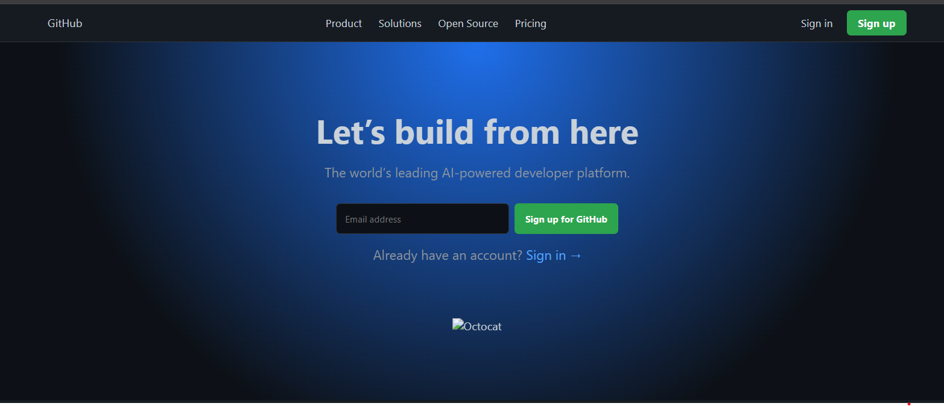

Above is a picture of the landing page.

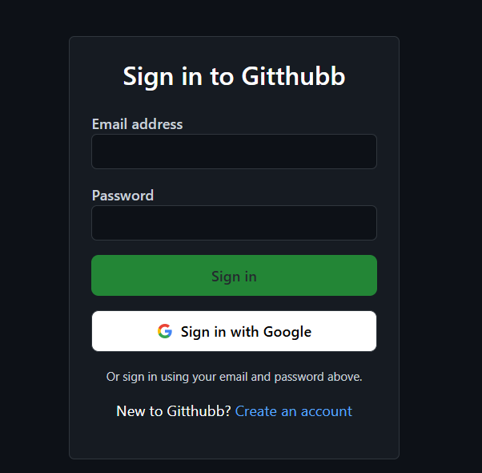

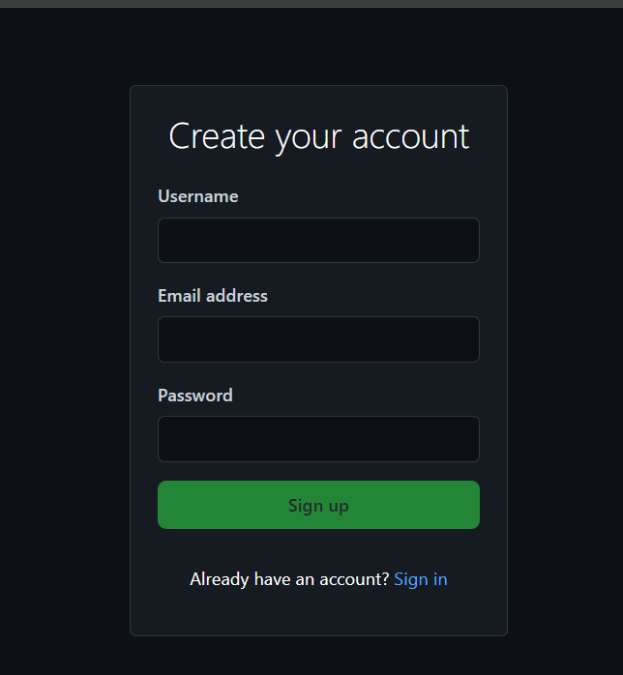

The pictures above are the sign in and and sign-up form

Below is a picture of the dashboard



Below is a picture of the repository

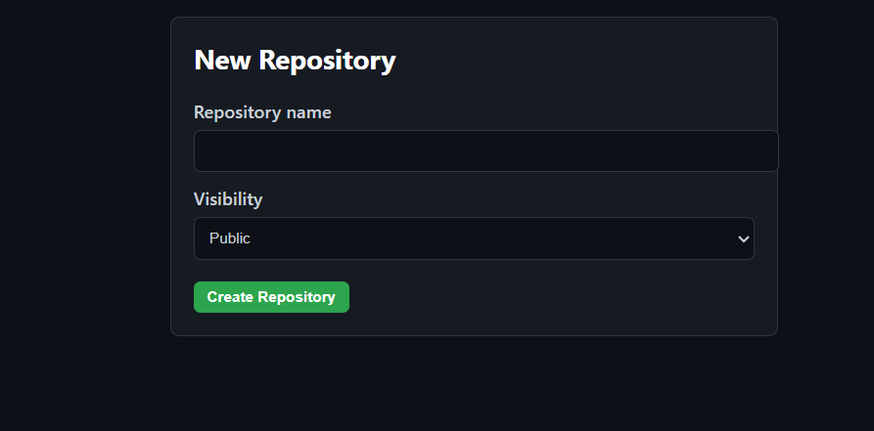

# 6. Challenges Faced

* Handling duplicate email errors in signup.
* Styling issues to make the UI look like GitHub’s.
* Linking pages together smoothly (login → dashboard → logout).

# 7. Learnings

* Improved knowledge of PHP-MySQL integration.
* Better understanding of HTML/CSS structuring.
* Learned error handling and validation in authentication.
* Importance of clean, reusable CSS for large projects.

# 8. Conclusion

The GitHub Clone project successfully replicates the basic features of GitHub including user authentication and repository management. It provided valuable hands-on experience in full-stack web development. In the future, additional features such as repository stars, commits, and user profile pages could be implemented.

# 9. References

* PHP Documentation – https://www.php.net/docs.php
* GitHub Official Site – https://github.com/